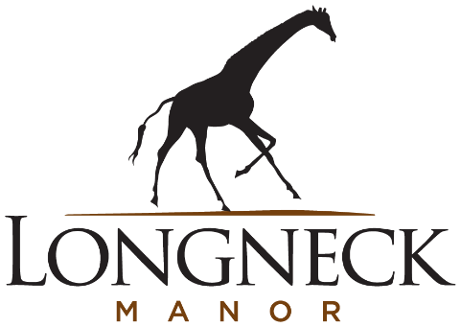
Meet the Giraffe Tower at Longneck Manor
A group of giraffe is called a Tower and Longneck Manor is currently home to a Tower of five reticulated giraffes (Giraffa reticulata): Kafele, Betty, Tana, Kili Rose, Indy.
Kafele is our male reticulated giraffe, born on November 17, 2015, at the San Diego, CA. and is just as dramatic a character as his name suggests. Kafele loves to be the center of attention and can be quite picky about who he interacts with. He is quite the lady’s man however, and loves spending time with our girls, Betty, Tana and Kili. He is very gentle with the new babies and younger members of the herd.
Betty is the true matriarch of the Tower and is also the oldest. She was born on January 17, 2015. She came to Longneck Manor from the Dallas Zoo along with her daughter, Tana. She is our most food motivated animal, always coming over to see if staff have any snacks. If the other giraffes are not quick enough, Betty is known to steal carrots right out of their mouth. We estimate that Betty is around 14 feet tall. Betty’s birthday is January 17th, 2015, and Betty shares the same Jan. 17 birthday as her Hollywood legend namesake, Betty White: a celebrated wildlife conservation champion and a longtime friend of Longneck Manor's founder, Rick Barongi
Tana came with her mother, Betty, from the Dallas Zoo. Tana was named after the longest river in Kenya and was born on July 29, 2020. Tana is our bravest giraffe. Her mother often utilizes Tana’s bravery to try out new things or new areas. Tana is a spunky and sassy giraffe, and the staff report she is a fast learner and loves to train with them. Tana’s birthday is July 29th, 202
Kili Rose is the second daughter born to Betty and the first baby giraffe born at Longneck Manor. Born on October 8, 2022, her birth took place inside the 10,000-square foot state-of-the-art giraffe barn. It was a family affair, with the other giraffe staying close by to protect Betty during labor, and to welcome their new family member, just as they would in the wild. Kili is headstrong and feisty and very, very smart. Kili’s name is short for Kilimanjaro, the tallest mountain in Kenya. Rick Barongi, our owner, was summitting Kilimanjaro the morning Kili was born!
Indy is a little spitfire and one of our smartest giraffes. He was born July 2, 2024, and is Betty’s third calf. His playful and adventurous spirit keep him busy and he’s up for anything. Indy is the second baby born here at Longneck Manor and has been close to big sister Kili from the start. They are typically found together getting into mischief of some sort.
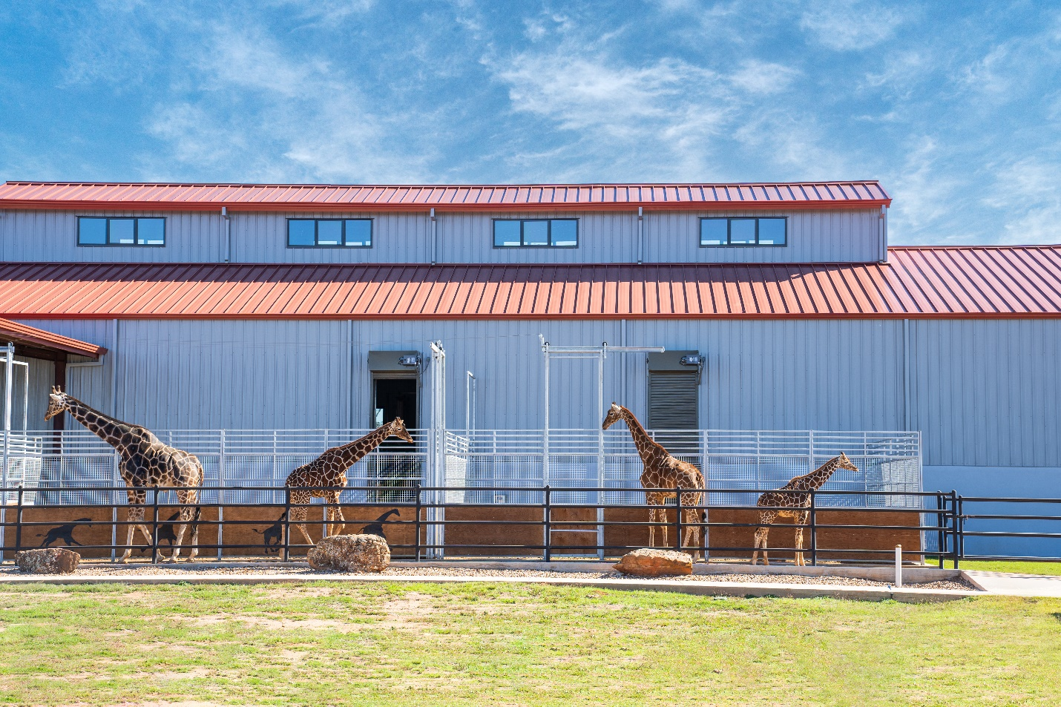

Fun Facts About Giraffes -
Giraffes have many interesting adaptations and are the tallest species alive. Male giraffes can reach up to 18 feet tall with females up to 16 feet. This height helps them reach food that other animals cannot reach. Once they reach full height, their only competition for the taller leaves are elephants. For comparison, our bull Kafele is estimated to be 16 feet tall.
They have 18-22-inch-long bluish-purple tongues. Their tongues are this color to help protect them from the harsh African (or Texas) sun.
Giraffe forage and eat for up to 18 hours a day and they typically get only about 4 hours of sleep cumulatively. They can sleep standing up with their eyes open.
Their only living relatives are okapis, an endangered species from Congo.
So, why care about giraffes? There are less than 100,000 giraffes left throughout Africa. Reticulated giraffes are considered Endangered according to the IUCN Red List. The threats to giraffes are all linked to competition with humans and livestock. This means that they are dealing with habitat loss, poaching, disease from livestock, even war and civil unrest affecting giraffes.
What is Longneck Manor doing to help giraffes in their natural habitat? At the forefront, Longneck Manor is a place to connect people with animal ambassadors. We work to inspire our guests to conserve through the relationships that they build with our giraffes. We created the Longneck Manor Conservation Foundation to help support several giraffe groups through your donations, and a portion of every Tour ticket and Overnight Stay goes directly to our conservation work.
Projects that Longneck Manor Conservation Foundation supports: ● Giraffe Conservation Foundation, Namibia. ● Save Giraffes Now, East Africa Giraffe Conservation Programs. ● Wild Nature Institute, Tanzania. ● Ruaha National Park, Tanzania – Giraffe translocations and skin disease studies. ● International Rhino Foundation – worldwide conservation programs for all five species of rhino.

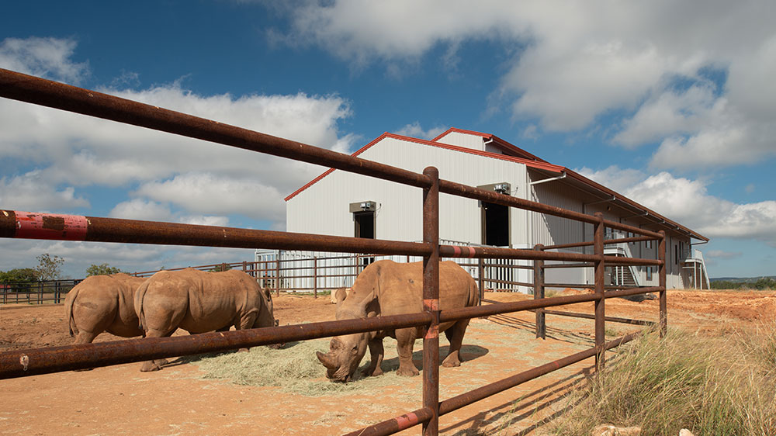

Meet Our Rhino Crash at Longneck Manor
As you may have guessed, a group of rhinos (Ceratotheriumm Simum) is called a Crash. Longneck Manor is home to three Southern White Rhinos: Barney, Fred and Justin.
Fred was named after none other than The Flintstones! He and his half-brother, Barney, come from White Oak Conservation in Yulee, FL. Fred tends to be a bit more timid about new situations, but leans on Barney to help bring out his confidence. He loves scratches and even rolls over for belly rubs. He and Justin are our two oldest rhinos, both born on February 7th, 2018. Fred can be identified by being the taller and leaner of the White Oak boys and weighs a little under 3,000 pounds!
Barney is named after The Flintstones just like his half-brother, Fred. He comes from White Oak Conservation in Yulee, FL. Barney is the shorter and rounder of the White Oak boys. Although he is younger than Fred, he is braver and often takes charge and investigates new things before his brother. Fred and Barney are very bonded as they’ve been together from birth. Barney’s birthday is February 21st, 2018, just two weeks younger than our other two rhinos. Barney weighs a little under 3,000 pounds.
Justin is from San Diego, CA. Justin is our largest rhino by far. He is a very vocal boy, letting us know exactly what he’s thinking by roaring, whining, growling or huffing! He is quite food motivated and will do just about anything for his favorite food, alfalfa. Out of our three boys, he tends to be the bravest rhino, exploring whatever new adventure he encounters. He also loves to shape his horn and has found it fun to “graffiti” the paddock wall with his horn. Justin’s birthday is February 7th, 2018 (same as Fred)! We estimate Justin is a little over 3,000 pounds.

Fun Facts About Rhinos-
The name rhinoceros means ‘nose horn’ from Ancient Greek. Rhinos have horns made up of keratin, which is the same fiber that humans have in their hair and fingernails. There are a total of five rhino species; two of the rhino species have one horn, while three of the rhino species have two horns.
The white rhino is also known as the square-lipped rhino due to the shape of its mouth. They are not white in color, instead they resemble more of a grey tone. However, rhinos can be seen covered in mud, especially in the hot summer months, to stay cool. Mudding themselves acts like sunscreen to protect them from the sun, as well as a bug repellent against insects.
White rhinos are the largest of the five rhino species, weighing up to 6000 pounds. Even at this size, rhinos can run up to 35mph.
Male rhinos mark the boundaries of their territory by urine spraying, as well as collectively sharing a poop pile, known as a midden. These are used by both male and females and act as territory boundaries and communication among individuals.
What Longneck Manor Is Doing to Help Rhinos In Their Natural Habitat?
When it comes to supporting wildlife conservation, most donors do a lot of research to find the organizations that provide the maximum impact for the causes that are most dear to them. Longneck Manor supports the philosophy of a well-known philanthropist, Miss Ellen Browning Scripps, who claimed never to have “donated” money to a worthy cause. Instead, she invested in them. The return on investment was not financial, and the dividends were measured in improving the quality of life for people and animals. Longneck Manor regularly donates to several impressive rhino conservation organizations such as the International Rhino Foundation and Care For The Wild.

