**Macintosh HD:Users:rodrickbarongi:Library:Containers:com.apple.mail:Data:Library:Mail Downloads:ADC957C3-3F25-4B31-B7DD-7ADBE6DD8451:LongNeckManorLOGO-FINAL2.pdf**

**Longneck Manor**

**September 2021**

**Vision**

Imagine a place where you can wake up with giraffes and rhinos right outside your door, and not have to travel all the way to Africa. Your day only gets better as you engage in special tours to learn and understand more about these magnificent animals and how you can help ensure their survival through active conservation efforts.

At Longneck Manor, some of the most iconic species of the African savannah will serve as animal ambassadors and storytellers, engaging with guests in unparalleled, personal encounters that will inspire a greater appreciation for these beautiful beasts and a desire to act on behalf of their wellbeing and survival in the wild.

**How**

Longneck Manor, nestled on 100 acres in the beautiful Hill Country of Texas, will serve as home to giraffe and rhino born in accredited US zoos and offer guests a personalized wildlife experience like no other in the country. Traveling to Africa – an exceptional experience only possible for very few, fortunate people – provides the only comparable experience to what Longneck Manor has to offer. Not a traditional zoo exhibit where barriers distance guests from personal encounters with the animals, Longneck Manor treats a small number of overnight guests to more of an immersive, exclusive safari experience.

Longneck Manor will be my personal residence where all guests will be made to feel at home with the people and animals they will meet during their stay. Everyone will be treated like a VIP and learn facts about animals that cannot be found in any textbook. The staff will share personal stories about the individual animals under their care, as well as their adventures in Africa. Opportunities will abound for guests to meet professionals who work in the field - perhaps a visiting conservationist from Africa or South America - and learn about what it is like working on the front lines of wildlife conservation.

Longneck Manor will combine opportunities for up close and personal animal interactions with the highest quality animal care and a commitment to conservation. Guests will be inspired to learn more about threats to these beautiful animals in the wild and the conservation efforts currently underway to protect them through unique and personal connections such as:

* Gazing into the beautiful eyes of a giraffe as its 18-inch tongue wraps around a leaf of lettuce you are holding.
* Witnessing the obvious enjoyment of a 4,000-pound white rhino as you pet him and scratch his back.

To achieve long-term results, conservation efforts require ongoing funding and the dedicated work of professionals in the field. By welcoming guests for a once-in-a-lifetime type of experience, Longneck Manor will help to support these efforts in two ways:

1. By designating a minimum of 10% of all earned revenues to specific conservation organizations and field biologists in Africa.
2. By raising awareness through development of personal connections between guests and our conservation ambassadors and highlighting projects and people with stories from the field to inspire every guest to take action.

An added benefit of Longneck Manor is that guests can be sure that the resources are going where they can have the most impact. There are many well-intentioned conservation organizations and field biologists, but some are more effective than others. Having spent the greater part of my career working with many of these organizations and conservationists, I am confident in my ability to pinpoint the most effective groups working in conservation today. I am a long-time board member of the International Rhino Foundation and other conservation organizations. After participating in more than 50 trips to over 18 African countries I have an in-depth knowledge of the challenges of wildlife conservation in many parts of Africa.

**Why**

I have had the distinct pleasure of getting to know these iconic animals of the African savannah intimately over the past 45 years through my work in some of the best zoos and safari parks in the country. Ever mindful of my deep admiration and respect for these endangered species and my fears for their survival, I now want others to share this emotional experience at Longneck Manor, my 140-acre wildlife conservation preserve in the Hill Country of Texas.

I have devoted my entire professional career to working with zoo animals as a zoo zoologist, director and conservationist. I have seen the transformation of good zoos into centers of excellence for animal care and conservation. At the same time wild populations of large mammals have decreased by over 50% and in the case of rhinos over 90% of their population has disappeared in the last 30 years. Ironically, while the standard of care for zoo animals has greatly improved, their wild counterparts face more pressure than ever to survive.

To return in part the great joy I have derived through my experiences with these animals, I now want to create a place that is not only a haven for resident zoo-born wildlife, but also a conservation park making a direct impact on saving these animals in the wild.

Nothing can duplicate a real African safari and watching large herds of animals roam past you on a seemly endless savannah. However, only a fraction of 1% of the American public will ever go on an African safari. Longneck Manor is intended to provide an authentic “taste of Africa” with real animals and stories of courage and hope. It is my hope that after a stay at Longneck Manor every guest will leave with a renewed sense of purpose for saving animals in the wild and join in the fight to save our planet and all its inhabitants.

For me it all comes down to a favorite quote:

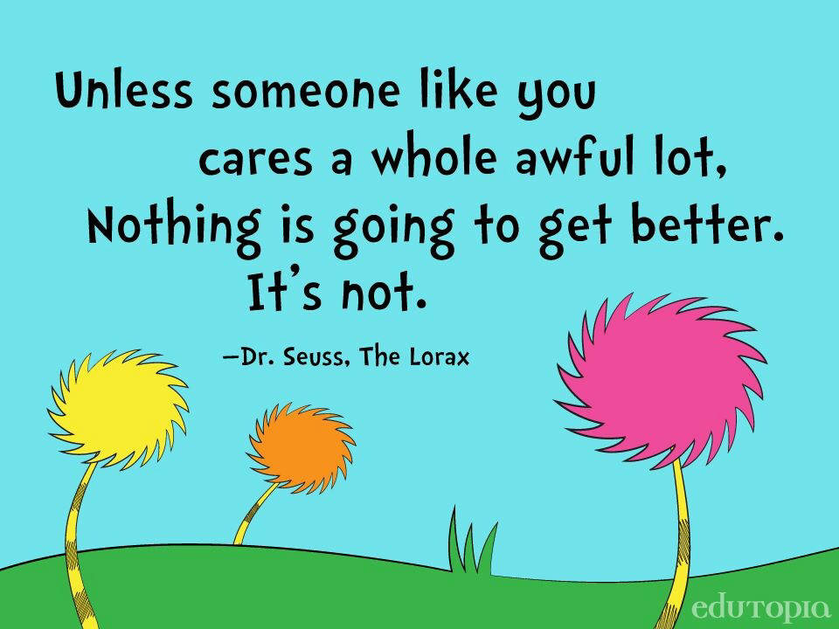

Rick Barongi

Founder and Conservationist

September 2021